**Cloud Computing Lab**

**Safa Jahangir**

**BSE-V B**

**2023-BSE-056**

**LAB 04**

## Task 1 – Verify VM resources in VMware

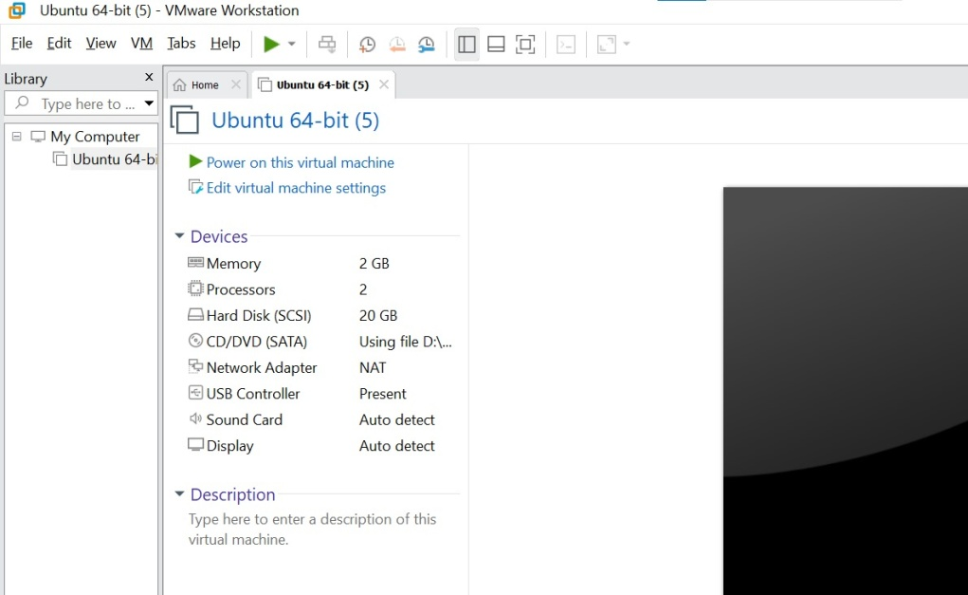

## Task 2 – Start VM and log in (use your preferred host terminal method only)

## vm\_login

## C:\Users\Laptop\AppData\Local\Packages\5319275A.WhatsAppDesktop_cv1g1gvanyjgm\TempState\74B83CC39B3B4A8B3B257EABEF47DC4C\WhatsApp Image 2025-10-16 at 21.24.45_e223b673.jpg

## whoami\_pwd

## C:\Users\Laptop\AppData\Local\Packages\5319275A.WhatsAppDesktop_cv1g1gvanyjgm\TempState\8F44BF343A8B3FF53D54EF6349935678\WhatsApp Image 2025-10-16 at 21.25.51_53b5aeae.jpg

## Task 3 – Filesystem exploration — root tree and dotfiles

* ls\_root.png

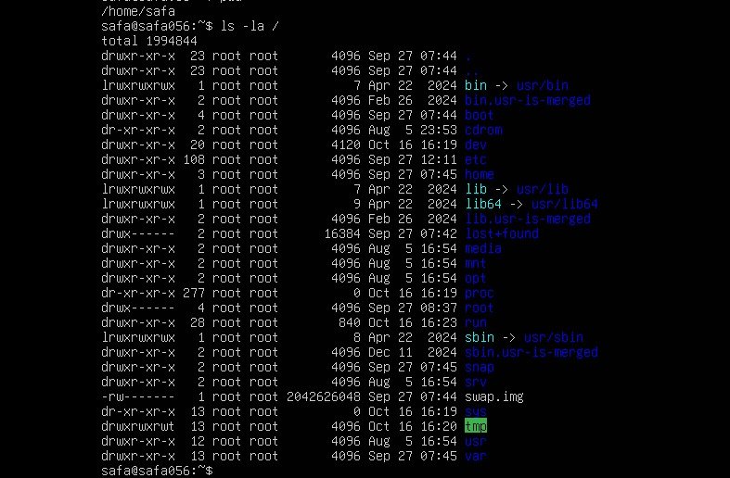

* os\_release.png

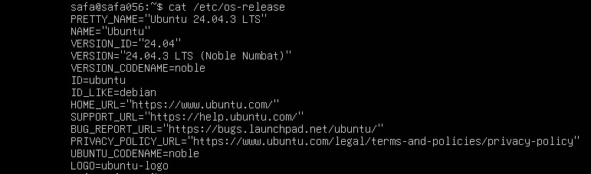

* ls\_bin.png

C:\Users\Laptop\AppData\Local\Packages\5319275A.WhatsAppDesktop_cv1g1gvanyjgm\TempState\70BA18DE159FDF9C69B9A8DB1FBDE805\WhatsApp Image 2025-10-16 at 21.37.36_2901edc1.jpg

* ls\_sbin.png

C:\Users\Laptop\AppData\Local\Packages\5319275A.WhatsAppDesktop_cv1g1gvanyjgm\TempState\4F1DCF7BBED48C7134C59CE539D0C69B\WhatsApp Image 2025-10-16 at 21.37.36_4862dc2a.jpg

* ls\_usr.png

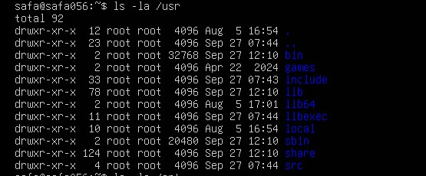

* ls\_opt.png

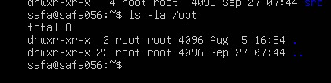

* ls\_etc.png

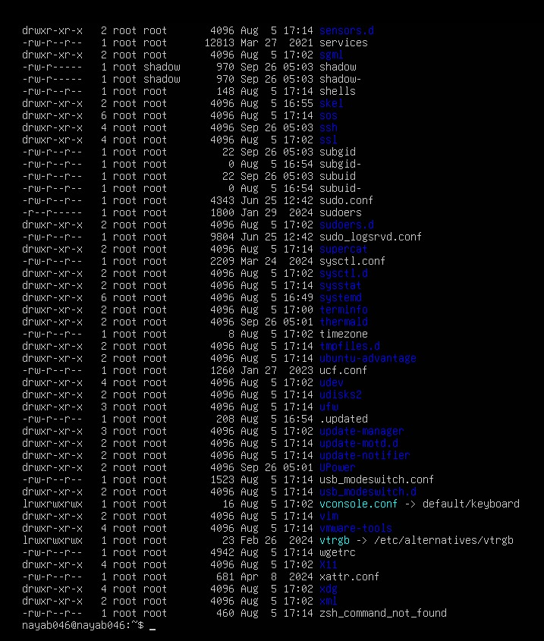

* ls\_dev.png

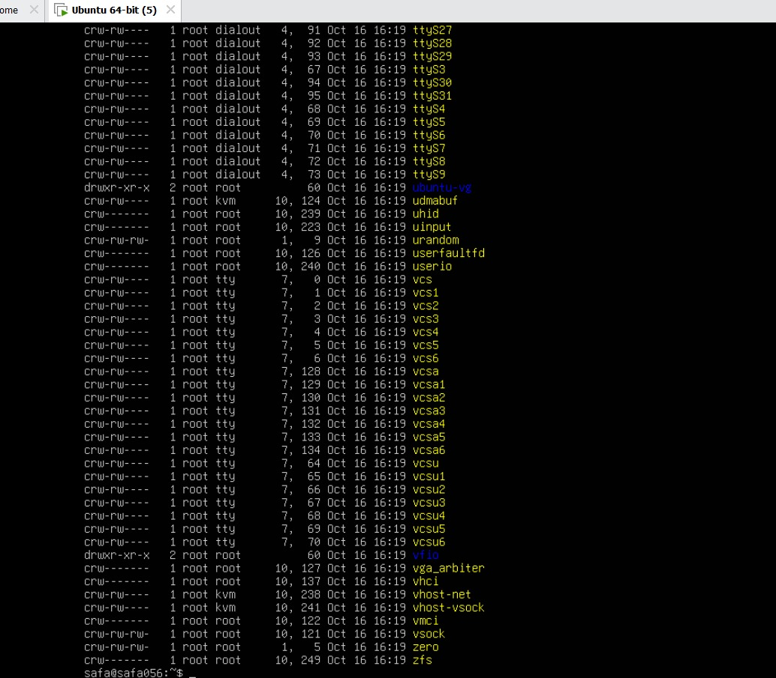

* ls\_var.png

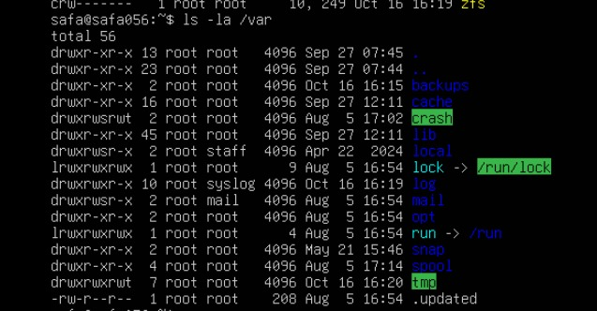

* ls\_tmp.png

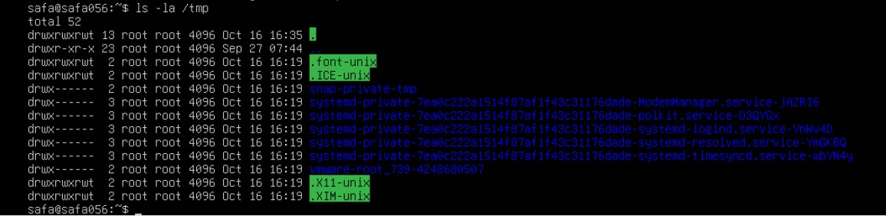

* home\_ls.png

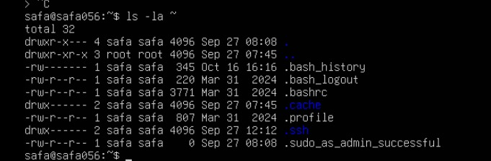

* answers\_md.png

## C:\Users\Laptop\AppData\Local\Packages\5319275A.WhatsAppDesktop_cv1g1gvanyjgm\TempState\EFD63D996AE783EC68036E7E61A784BF\WhatsApp Image 2025-10-16 at 22.18.50_d341785d.jpg

## Task 4 – Essential CLI tasks — navigation and file operations

* mkdir\_workspace.png

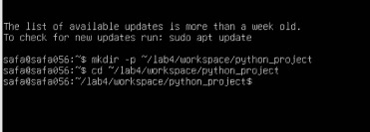

* cd\_workspace.png



* pwd\_workspace.png

C:\Users\Laptop\AppData\Local\Packages\5319275A.WhatsAppDesktop_cv1g1gvanyjgm\TempState\F78038FAE7EB96B2DA8FD7EFAF12E2DF\WhatsApp Image 2025-10-17 at 10.56.37_f405a0e3.jpg

* nano\_readme.png

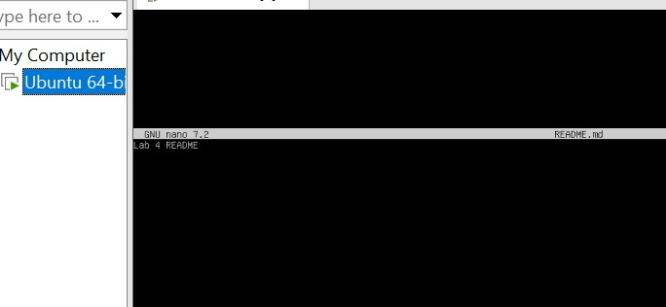

* nano\_main.png

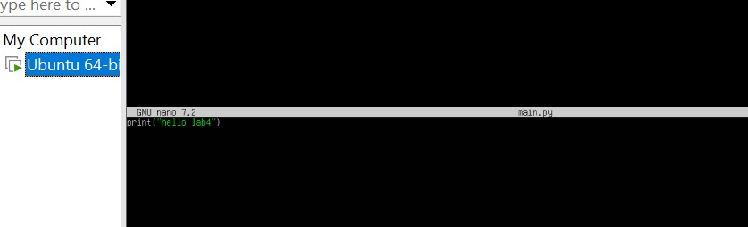

* nano\_env.png

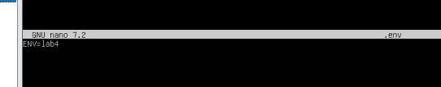

* works pace\_ls.png 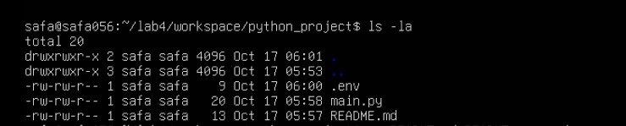
* cp\_readme.png

C:\Users\Laptop\AppData\Local\Packages\5319275A.WhatsAppDesktop_cv1g1gvanyjgm\TempState\4AE4DD4C5651CD27464724897852E777\WhatsApp Image 2025-10-17 at 11.08.43_f4398778.jpg

* mv\_readme.png

C:\Users\Laptop\AppData\Local\Packages\5319275A.WhatsAppDesktop_cv1g1gvanyjgm\TempState\F13E92096144B91A3460352FC34655AD\WhatsApp Image 2025-10-17 at 11.09.20_fed0c339.jpg

* rm\_readme.png C:\Users\Laptop\AppData\Local\Packages\5319275A.WhatsAppDesktop_cv1g1gvanyjgm\TempState\AED0F5F7345412401D7F9A2328F3DE68\WhatsApp Image 2025-10-17 at 11.09.40_b6bb5915.jpg
* mkdir\_java\_app.png



* cp\_recursive.png



* copy\_verify.png

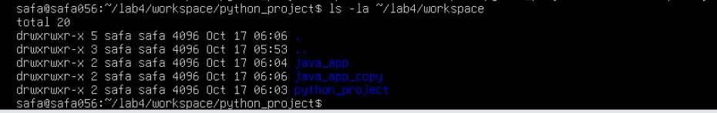

* history.png

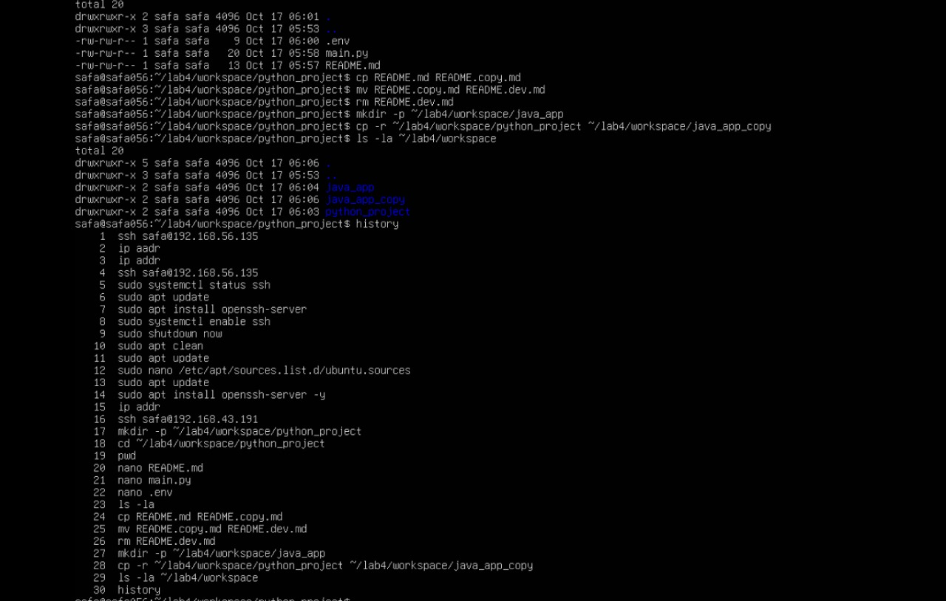

* tab\_completion.png

C:\Users\Laptop\AppData\Local\Packages\5319275A.WhatsAppDesktop_cv1g1gvanyjgm\TempState\80A2399E48C8BB8B6C2832DF02C43AC9\WhatsApp Image 2025-10-17 at 11.17.47_fcef643c.jpg

## Task 5 – System info, resources & processes

* uname.png



* cpuinfo.png

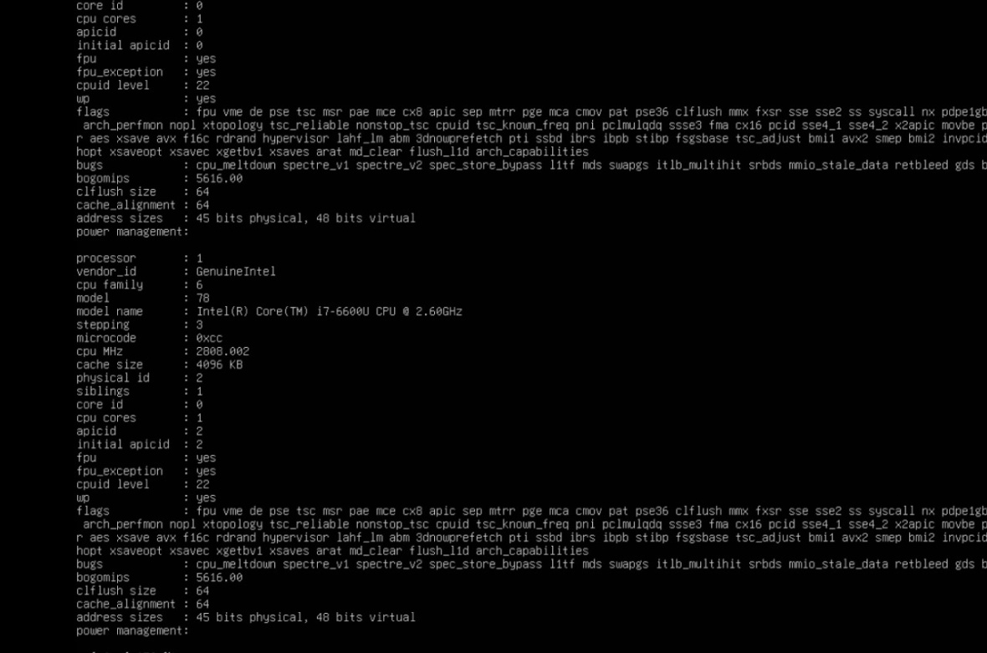

* meminfo.png

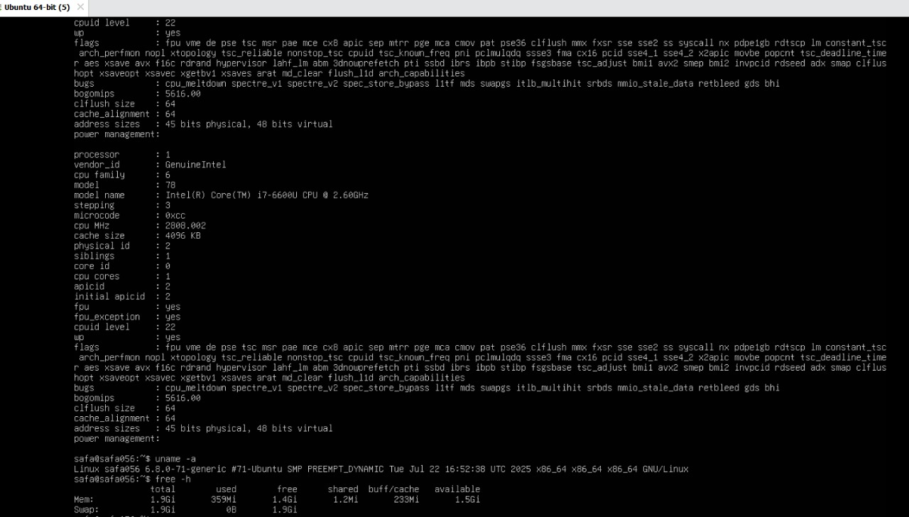

* diskinfo.png

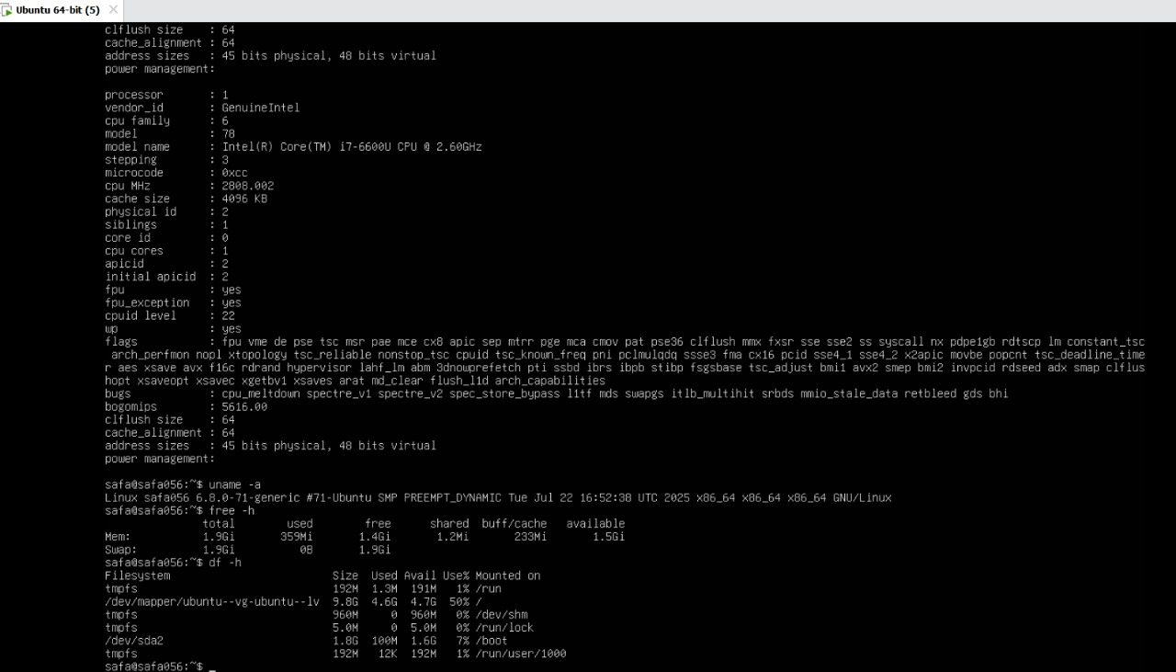

* os-release.png

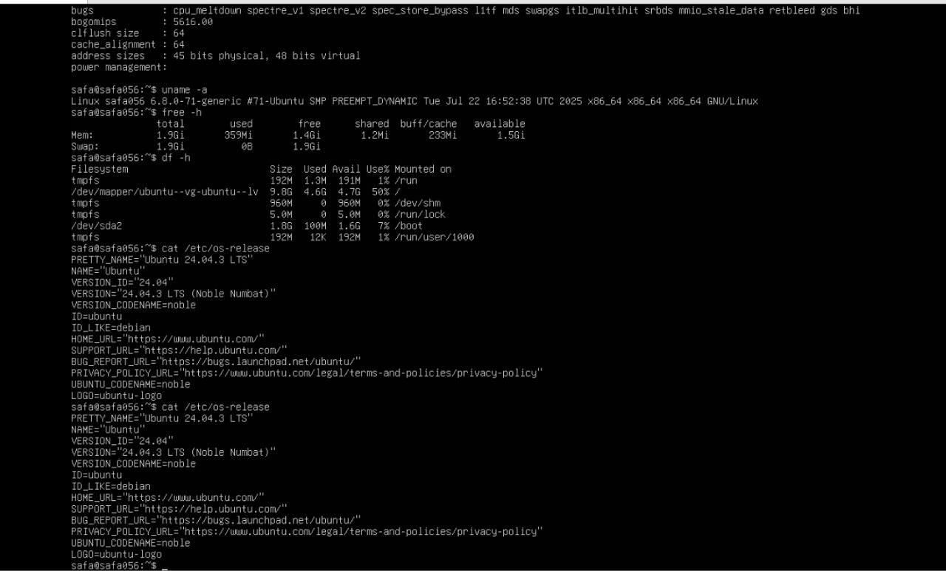

* processes.png

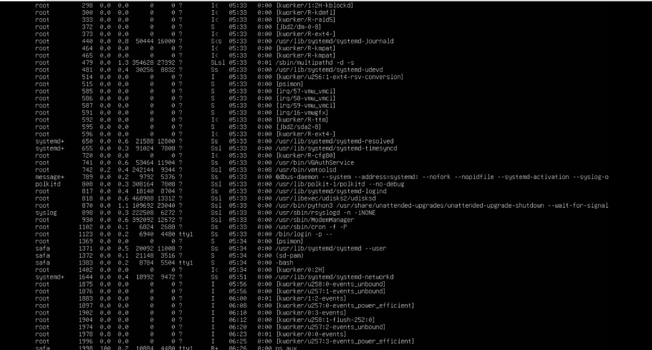

## Task 6 – Users and account verification (no sudo group change)

* adduser\_lab4user.png

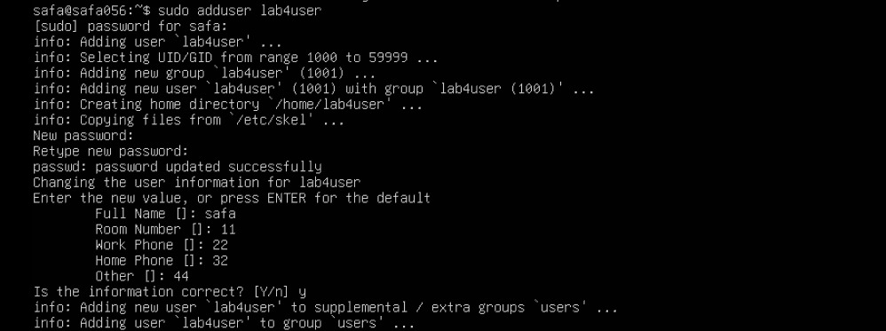

* lab4user\_passwd.png

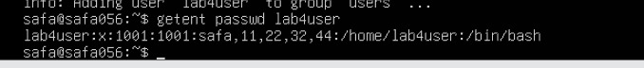

* su\_lab4user.png

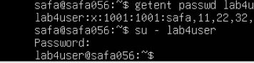

* sudo\_whoami.png

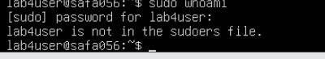

* exit\_back.png

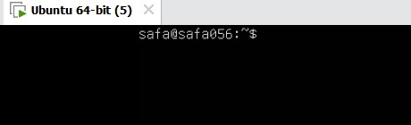

* (optional) deluser.png

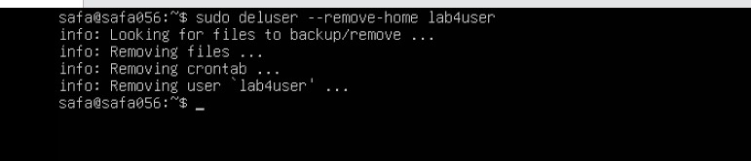

## Bonus Task 7 – Create a small demo script using an editor and run it

* nano\_run\_demo.png 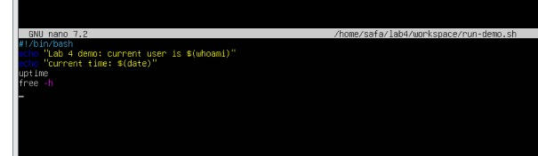
* chmod\_run\_demo.png



* run\_demo\_output.png

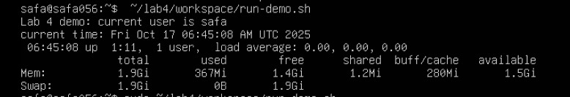

* run\_demo\_output\_sudo.png (optional)

